ICS 103: Computer Programming in C
Handout-15 Topic: STRINGS
Objective:

- To know what is string and how to handle it?
- To know how to read and print Strings.
- To know about some important built-in string functions and how to use them?

What is String?

A string is any sequence of characters enclosed in double quotes. There is no separate data type for strings as integer, float or double. The string data type can be considered as a char array. The difference is that a character variable can hold only one character but a string can have more than one character in a character array. For example, a string called name with 9 characters can be declared as:

char name [9] = “I like C” ;

Check for the double quotes, the char array size 9. Here the name can be considered as one string or as an array of characters. That is if you refer name it is “I like C” and if you refer name[0] it is ‘I’, name[1] is ‘ ‘ (a blank), name[2] is ‘l’, name[3] is ‘i’, and so on. The last character name[8] is ‘\0’ which indicates a NULL character which is not displayed but is stored as last character of the string to indicate its end.

Note: Strings are stored as arrays of characters and have a special ‘\0’ termination character called NULL appended (attached) to them to signify the end of the string.

Note that if the number of characters including the ‘\0’ is more than the size of the array the results will be unpredictable. However, if the size of the array is more than the number of characters the extra spaces after the last ‘\0’ character are kept blank and not referred because the string ends at ‘\0’. So, always make sure that the size of the array is sufficient for the string. For example, the above declaration would be wrong if we write
char name [8] = “I like C” ;

The size can be ignored also. In that case the size is considered as that of the number of characters specified in the declaration.
char name [ ] = “I like C” ;

String Input/Output:

The easiest way to input strings is by using the C library function gets (means get string). The gets( ) function reads a string of characters entered at the keyboard until you strike the enter key (carriage return). The carriage return does not become part of the string; instead a null terminator ‘\0’ is placed at the end.
For example, in the following program fragment
char str[80] ;

gets (str) ;
and if the user enters
Rafiqul Zaman Khan

and presses the enter key the string variable str has the characters “Rafiqul Zaman Khan” with ‘\0’ appended at the end but is not displayed.
Similarly, there is an output function puts ( ) which prints or displays the value of the string variable. Unlike the printf, which stays on the same line after printing puts automatically advances the output to the next line after displaying it.

puts (str) ;

Example:
char name [81] = {“Rafiqul Zaman Khan”} ;
gets (name) ; /* reads the name */
puts (name) ; /* prints the name */

You can also use the scanf function for string input by means of the %s format specifier and the printf function for string output. But the disadvantage with it is that scanf interprets a blank as the end of the particular input value. As a result you can’t read the above line Rafiqul Zaman Khan with scanf using a single string variable. You need to take 3 string variables to read the 3 words as

char first[10], second[10], third[10] ;

scanf (“%s %s %s”, first, second, third) ;
printf (“My name is : %s %s %s\n”, first, second, last ) ;

Note that there is no & (address of) operator for string variables when they are read with scanf.

Example 1:

#include <stdio.h>

int main() {

char words[80];

printf("enter a sentence then press enter >");

//scanf("%s",words);

gets(words);

printf("you entered\n");

puts(words);

printf("you entered\n%s",words);

return 0;

}

Built-in String Functions:

Large collections of string processing functions are provided in C through string.h file. So, include the string.h file in the programs to use these functions. To use the string functions make sure that the size of the array is sufficient so that the strings are terminated with the ‘\0’ character or the functions will not work properly.

strcat ( string1, string2 ) :

The strcat function concatenates or joins the string1 and string2. A copy of string2 is put at the end of the string1. Make sure that string1 size is long enough to hold the resulting string (string1 + string2).

Example 2:

#include <stdio.h>
#include<string.h>
int main() {
char string1[10] = "abc", string2 [ ] = "def" ;
strcat ( string1, string2) ;
puts ( string1 ) ; /* outputs "abcdef" which is stored in string1 */
return 0;
}

strcpy ( string1, string2 ) :

The strcpy function copies string2 into string1. Again make sure that string1 size is long enough to hold the resulting string.

Example 3:
#include <stdio.h>
#include<string.h>
int main() {
char string1 [81], string2 []= "memory" ;
strcpy (string1, string2 ) ;
puts(string1) ; /* outputs "memory" copied into string1 */
return 0;
}

strcmp ( string1, string2 ) :

The strcmp function compares the string1 to string2 and returns an integer value to show the status of the comparison. A value of 0 indicates that the two strings are identical. A value of less than 0 shows that string1 is lexicographically (according to alphabetic ordering) less than string2. A value of greater than 0 shows that string1 is lexicographically (according to alphabetic ordering) greater than string2.

Example 4:
#include <stdio.h>
#include<string.h>
int main() {
char string1 [ ] = "ics 103" ;
char string2 [ ] = "ics 103" ;
char string3 [ ] = "Ics 103" ;
char string4 [ ] = "kcs 103" ;
printf ( "%d %d %d", strcmp (string1, string2), strcmp (string1, string3),
strcmp (string1, string4) ) ; /* outputs 0, >0, <0 */
return 0;
}

Note that when the strings are not equal the result is positive or negative and not the exact value.

strlen ( string1 ) :

The strlen function returns an integer equal to the length of the stored string including blanks, not including the termination character.

Example 5:
#include <stdio.h>
#include<string.h>
int main() {
char string1 [80] ;
char string2 [ ]= "Kfupm Dhahran" ;
string1[0]='\0';
printf ("%d %d", strlen ( string1 ), strlen ( string2 ) ) ; /* outputs 0 for string1, 8 for string2 */
return 0;
} /* outputs 0 for string1, 13 for string2 */

strchr ( string, ch ) :

The strchr function searches string for the first occurrence of ch. This function only tells whether the string contains ch or not and it will not tell the position of the ch in the string if found. If the character ch is not present in the string, it will return NULL

Example 6:
#include <stdio.h>
#include<string.h>
int main() {
char string [12] = "ICS 103 061" ;
char search = 'A' ;
if ( strchr (string, search )!= NULL )
printf ("Search character found\n") ; /* outputs this message */
else
printf ("Search character not found\n") ;
return 0;
}

Solved Problems:

/**************************************************************************
Problem#1:
Write a program that initializes a character array first of size 20 ,
character array last of size 20. Array first contains the first name , array last contains the last name. Then, array first joins the two strings together first and last .

**************************************************************************/
#include<stdio.h>
#include<string.h>

void main()
{
char first[20];
char last[20];

printf("Plz Enter your first name :");
gets(first);

printf("Plz Enter your last name :");
gets(last);

strcat(first, last); // it joins last into first

printf("\nYour full name is : ");
puts(first);

} // end of main

Sample Output:

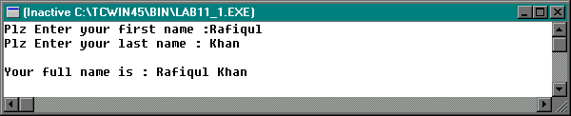

/***************************************************************************
Program # 2:

Write a program that uses 5 strings str1, str2, str3, str4, str5 each of size 81.
Let str1="what", str2 = "whatsoever, str3 = "ever", str4 = "whatever".
Then it should do the following:

Join str3 to str1 and print str1.
Copy str1 to str5 .
Compare str5 and str4 and print whether they are equal or not.
Find the length of the string str1 and print it.
Check whether the character 'w' occurs in both strings str2 and str3
and print "yes" if it occurs otherwise print "No".

Use puts ( ) function for printing strings.

**************************************************************************/
#include<stdio.h>
#include<string.h>
void main()
{
int i, length_str1;
char str1[81]="what";
char str2[81]="whatsoever";
char str3[81]="ever";
char str4[81]="whatever";
char str5[81];

strcat(str1,str3); // it joins str3 with str1 and assigns result to str1.
puts("After joining str3 with str1 , the new str1 is :");
puts(str1);
strcpy(str5,str1); // it copies str1 into str5.
puts("After copying str1 into str5, the new str5 is :");
puts(str5);
i=strcmp(str5,str4); // it returns 0 when str5 and str4 are equal.
if(i==0)
puts("str5 and str4 are equal");
else
puts("str5 and str4 are not equal");

length_str1=strlen(str1); //it calculates length of str1.
printf("The length of str1 is : %d ",length_str1);

if(strchr(str2,'w')!=NULL && strchr(str3,'w')!=NULL)
puts("\nYes");
else
puts("\nNo");

} // end of main

Sample Output:

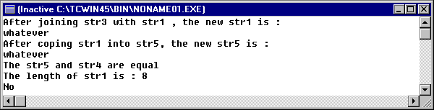

Character related standard Library Functions in C :

C provides a family of character-related Standard functions that facilitate
character manipulations.

To use these functions #include <ctype.h> header file is used.

List of character related functions is given below:

Name | Description | Example | Return
isalnum | Tests for alphanumeric | isalnum(‘a’) | 0 (false) nonzero (true)
isalpha | Tests for alphabetic | isalpha(‘a’) | 0 (false) nonzero (true)
iscntrl | Tests for control character | iscntrl(‘\n’) | 0 (false) nonzero (true)
isdigit | Tests for digit | isdigit(‘1’) | 0 (false) nonzero (true)
islower | Tests for lowercase charater | islower(‘a’) | 0 (false) nonzero (true)
isupper | Tests for uppercase character | isupper(‘A’) | 0 (false) nonzero (true)
ispunct | Test for punctuation character | ispunct(‘!’) | 0 (false) nonzero (true)
isspace | Tests for whitespaces character | isspace(‘ ‘) | 0 (false) nonzero (true)
toupper | Converts characters to uppercase | toupper(‘a’) | A
tolower | Converst characters to lowercase | tolower (‘A’) | a

Example:
#include<stdio.h>
#include<string.h>
#include<ctype.h>
int main()
{
char message[ ]="ICS 103 : Computer Programming in C (Term061)";
int stop=strlen(message),i;
for ( i=0 ; i< stop ; i++)
//putchar(tolower(message[i]));
message[i]= tolower(message[i]);
puts(message);
return 0;
}
Sample Output:
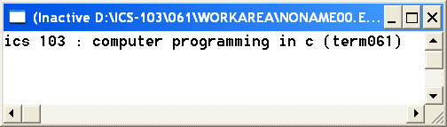

Example:

#include <stdio.h>
#include <ctype.h>
#include <string.h>
int main(void) {
int i,countup,countlow;
int countspace,countdigit,countpunc,countcontrol_c;
char str[80] = " ICS 103 Computer Programming in C !!";
i=countup=countlow=countspace=countdigit=countpunc=countcontrol_c=0;
puts(" 1 2 3 4 5");
puts("12345678901234567890123456789012345678901234567890123");
puts(str);
printf("the length of the string is %d\n",strlen(str));
while(str[i] !='\0')
{
if(ispunct(str[i]))
countpunc++;
if(iscntrl(str[i]))
countcontrol_c++;
if(isdigit(str[i]))
countdigit++;
if(isspace(str[i]))
countspace++;
if(isupper(str[i]))
countup++;
if(islower(str[i]))
{
countlow++;
str[i] = toupper(str[i]);
}
i++;
}
printf("The number of digits = %d\n",countdigit);
printf("The number of spaces = %d\n",countspace);
printf("Upper case letters = %d\n", countup);
printf("Lower case letters = %d\n", countlow);
printf("Punctuation characters = %d\n",countpunc);
printf("Total control characters = %d\n", countcontrol_c);
printf("%s\n", str);
return 0;
}

Sample Output :

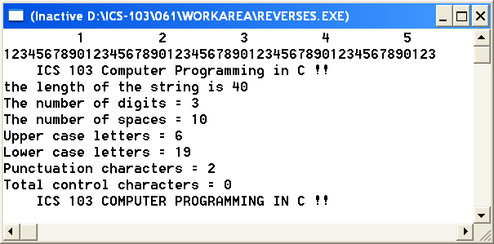

Example:

Problem: Write a program that reads a string and print the number of vowels, number of upper case and number of lower case letters. It should also print the string with the first letter capitalized and the remaining in lower case.

Solution:
#include <stdio.h>
#include <string.h>
#include <ctype.h>
int isvowel(char ch); // Function Prototype
int main( )
{
char str[81];
int len, i, nvowel=0, nupper=0, nlower=0;
printf("Enter your string >");
gets(str);
len=strlen(str);
for (i=0; i<len; i++){
if (isvowel(str[i]))
nvowel++;
}
for (i=0; i<len; i++){
if isalpha(str[i])
if (isupper(str[i]))
nupper++;
else
nlower++;
}
str[0]=toupper(str[0]);
for (i=1; i<len; i++)
str[i]=tolower(str[i]);
printf("Number of vowels = %d\n", nvowel);
printf("Number of lower case = %d\n", nlower);
printf("Number of upper case = %d\n", nupper);
printf("Capitalised string = %s\n", str);
return 0;
}
/* returns true if a given character is a vowel */
int isvowel(char ch)
{ int vowel;
char lower=tolower(ch);
vowel=lower=='a' ||lower=='i' ||lower=='o' ||
lower=='u' ||lower=='e';
return vowel;
}

Sample Output:

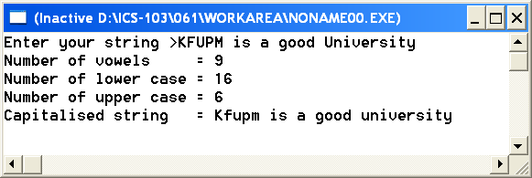

Printing Characters
Char | Decimal  code | Description
SP | 32 | Space
! | 33 | Exclamation mark
" | 34 | Quotation mark (&quot; in HTML)
# | 35 | Cross hatch (number sign)
$ | 36 | Dollar sign
% | 37 | Percent sign
& | 38 | Ampersand
` | 39 | Closing single quote (apostrophe)
( | 40 | Opening parentheses
) | 41 | Closing parentheses
* | 42 | Asterisk (star, multiply)
+ | 43 | Plus
, | 44 | Comma
- | 45 | Hyphen, dash, minus
. | 46 | Period
/ | 47 | Slash (forward or divide)
0 | 48 | Zero
1 | 49 | One
2 | 50 | Two
3 | 51 | Three
4 | 52 | Four
5 | 53 | Five
6 | 54 | Six
7 | 55 | Seven
8 | 56 | Eight
9 | 57 | Nine
: | 58 | Colon
; | 59 | Semicolon
< | 60 | Less than sign (&lt; in HTML)
= | 61 | Equals sign
> | 62 | Greater than sign (&gt; in HTML)
? | 63 | Question mark
@ | 64 | At-sign
A | 65 | Upper case A
B | 66 | Upper case B
C | 67 | Upper case C
D | 68 | Upper case D
E | 69 | Upper case E
F | 70 | Upper case F
G | 71 | Upper case G
H | 72 | Upper case H
I | 73 | Upper case I
J | 74 | Upper case J
K | 75 | Upper case K
L | 76 | Upper case L
M | 77 | Upper case M
N | 78 | Upper case N
O | 79 | Upper case O
P | 80 | Upper case P
Q | 81 | Upper case Q
R | 82 | Upper case R
S | 83 | Upper case S
T | 84 | Upper case T
U | 85 | Upper case U
V | 86 | Upper case V
W | 87 | Upper case W
X | 88 | Upper case X
Y | 89 | Upper case Y
Z | 90 | Upper case Z
[ | 91 | Opening square bracket
\ | 92 | Backslash (Reverse slant)
] | 93 | Closing square bracket
^ | 94 | Caret (Circumflex)
_ | 95 | Underscore
` | 96 | Opening single quote
a | 97 | Lower case a
b | 98 | Lower case b
c | 99 | Lower case c
d | 100 | Lower case d
e | 101 | Lower case e
f | 102 | Lower case f
g | 103 | Lower case g
h | 104 | Lower case h
i | 105 | Lower case i
j | 106 | Lower case j
k | 107 | Lower case k
l | 108 | Lower case l
m | 109 | Lower case m
n | 110 | Lower case n
o | 111 | Lower case o
p | 112 | Lower case p
q | 113 | Lower case q
r | 114 | Lower case r
s | 115 | Lower case s
t | 116 | Lower case t
u | 117 | Lower case u
v | 118 | Lower case v
w | 119 | Lower case w
x | 120 | Lower case x
y | 121 | Lower case y
z | 122 | Lower case z
{ | 123 | Opening curly brace
| | 124 | Vertical line
} | 125 | Closing curly brace
~ | 126 | Tilde (approximate)
DEL | 127 | Delete (rubout), cross-hatch box

